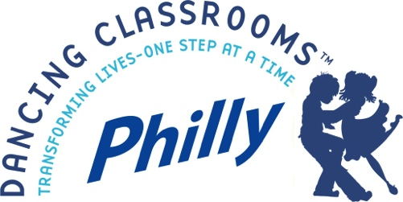

10th Anniversary Colors of the Rainbow Team Match Final

Dancing Classrooms Philly’s 10th Anniversary Colors of the Rainbow Team Match Final will take place on Sunday, June 4, 2017 at Levitt Auditorium, University of the Arts, 401 South Broad Street, Philadelphia from 2:00 – 4:00pm.

This exciting, everybody-up-on-their-feet event brings together ten teams of gold-level winners from DCP’s Fall and Spring Semester Final student events. Cheering on the dance teams are hundreds of family members and friends, DCP teaching artists and staff, as well as organizational donors and funders. The afternoon combines graceful and elegant ballroom dance with friendly (and enthusiastic) competition – an inspiring and family-friendly event, truly enjoyed by all ages. Photos from previous Final events can be found on our website at http://dancingclassroomsphilly.org/colors-of-the-rainbow-2/

Event sponsors will receive print, electronic and announcement recognition at the Final event. Advance recognition is included in some sponsorship levels (see sponsorship information). Attendance at the Final is anticipated to be approximately 800 people.

Dancing Classrooms Philly (DCP) is an arts education program based on Dancing Classrooms, the highly acclaimed American Ballroom Theater Company program, created in New York City by Broadway dancer and show‐dance champion Pierre Dulaine. DCP was launched in Philadelphia in the Fall of 2007. The mission of the program is to foster self-esteem, social awareness and joy in children by providing the opportunity to learn and perform ballroom dance.

Thank you for your interest in our 10th Anniversary Colors of the Rainbow Team Match Final. For questions, please contact Juliette Hyson, Director of Individual Giving at 215.829.9522 x107 or at Juliette@musicopia.net.

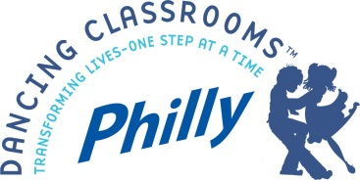

10th Anniversary Colors of the Rainbow Team Match Final
Sponsorship Opportunities

Sunday, June 4, 2017

$2,500 – Tango Sponsor

- Sponsorship recognition as Lead Sponsor on print and electronic invitations (Deadline: March 31), in press releases, as well as through social media event postings distributed to over 3,500
- Banner recognition with logo prominently displayed at Final event (approximately 800 in attendance)
- Recognition as Lead Sponsor in event program
- Includes all benefits from levels listed below

$1,000 – Swing Sponsor

- Prominent sponsorship recognition by Mistress of Ceremonies
- One-time recognition with company logo in e-newsletter distribution to DCP’s and Musicopia’s (DCP’s partner organization) electronic mailing list (approx. 4,000)
- Includes all benefits from levels listed below

$500 – Fox Trot Sponsor

- Signage including company logo on lobby display at event
- Includes benefits from level listed below

$250 – Merengue Sponsor

- Listing including company logo in event program (approx. 800 attendees)
- Listing included in event press release
- Recognition in annual report distributed to more than 125 donors and funders and posted on DCP website
For questions or further information, call Juliette Hyson at 215-829-9522 ext.107 or email: juliette@musicopia.net

