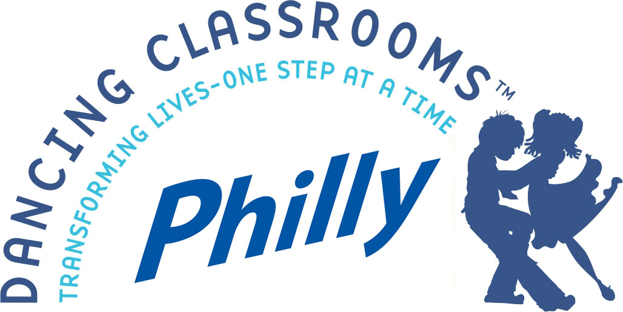

ATTENTION: DANCING CLASSROOMS PHILLY GRADUATES,
WEEKEND CLASSES WILL OFFER NEW AND CHALLENGING MOVES!

Dancing Classrooms Philly continues the DCP Academy for students in grades 5 – 6 who have participated in the program in their schools. The curriculum is designed to challenge students with new steps and techniques to move dancers to the next level. The year will conclude with the DCP Academy Festival, bringing together all three Academy sites and our performance troupe.

Students can attend the 10 class session and the DCP Academy Festival for the low cost of $6.00 per class – that’s only $60.00 total! Full payment must be received by check or money order on or before the first lesson.
There are no refunds after December 31st, 2019.

Schedule: Classes begin January 2020.

Time: 9:00AM-10:00AM

Locations: West Philly – University City Arts League
4226 Spruce St, Philadelphia, PA 19104

North East – St. Christopher School
13305 Proctor Road, Philadelphia 19116

South Philly – CHI Movement Arts Center
1316 South 9th Street, Philadelphia 19147

Please mail the enrollment, liability form, and payment to:
Dancing Classrooms Philly, 4226 Spruce St, Philadelphia, PA 19104

Money orders or checks should be made payable to Arts in Schools Collaborative /Dancing Classrooms Philly. Please put your child’s name on the check or money order. For additional information, please email info@dancingclassroomsphilly.org or call (215)268-3973.

Space is limited and registrations will be taken in the order they are received. If your child is unable to attend for any reason, please let us know that they are withdrawing, so we may open that space for someone else.

Dancing Classrooms Philly – Half Year Registration

*** Location (circle one) - North East, West Philly, South Philly

Student Information (please print)

Name: ________________________________________

Address: _________________________________________________ Zip ___________

Current School _______________________________ Current Grade ______________

Phone: _____________________________ ______________________________
(Home) (Cell)

E-Mail: ________________________________________________________________

Check or money order #____________________________________________________

Release of Liability
I understand that dancing, like other forms of exercise, carries with it an inherent risk of injury. I acknowledge that I assume that risk and will not hold Dancing Classrooms Philly or its staff liable for any injuries and/or property damage that may occur during the course of my child’s participation in the instructional activities that I am contracting for herein. Furthermore, for my child’s own well-being and as an inducement and assurance to Dancing Classrooms Philly to provide me with the referenced lessons contracted for, I certify that my child is in good health, good physical condition and capable of participating in the physical activity required by this class.
Yes_____ No_______

I give permission for my child’s picture or video to be released for promotional use only including television, website, brochure and newspaper article or newsletter.
Yes_____ No_______

I would like to receive the DCP electronic newsletter, to stay current on upcoming news, events, and program highlights.
Yes_____ No_______

I have read and agree to all the above conditions:

Parent or Guardian Name (print) _________________________________________________

Signature __________________________________________ Date _____/______/______

